Flood Monitoring and Alert System

Components and Steps:

1.Water Level Sensors:

Use water level sensors connected to microcontrollers (e.g., Arduino) to measure water levels in rivers, streams, or flood-prone areas. Tinker-cad allows you to simulate these components.

2.Data Transmission:

Utilize IoT technology (Wi-Fi or LoRa) to transmit the sensor data to a central database or cloud platform. You can simulate this data transmission in Tinker-cad.

3.Data Analysis:

Develop algorithms to analysis the incoming data in real-time. Trigger alerts when water levels reach critical levels, indicating a potential flood.

4. Alert System:

Implement a notification system, such as SMS or email alerts, to notify authorities and residents when a flood risk is detected.

5. Visualization:

Create a user-friendly dashboard to visualize real-time water level data. You can use Tinker-cad to design a simplified interface.

6. Integration with Emergency Services:

Explore the possibility of integrating the system with local emergency services, enabling them to respond quickly to flood alerts.

7. Power Management:

Incorporate power-saving features to ensure the system can run efficiently for extended periods, possibly using solar panels or energy-efficient components.

8. Education Component:

Since this is a student project, consider adding an educational aspect. Create informative materials or presentations about flood control and the importance of early warning systems.

9. Testing and Simulation:

Continuously test the system in Tinker-cad to refine its performance and responsiveness. 10. Documentation: Document the entire project, including design, code, and results, to showcase the learning process and Outcomes.

10. Documentation:

Document the entire project, including design, code, and results, to showcase the learning process and Outcomes.

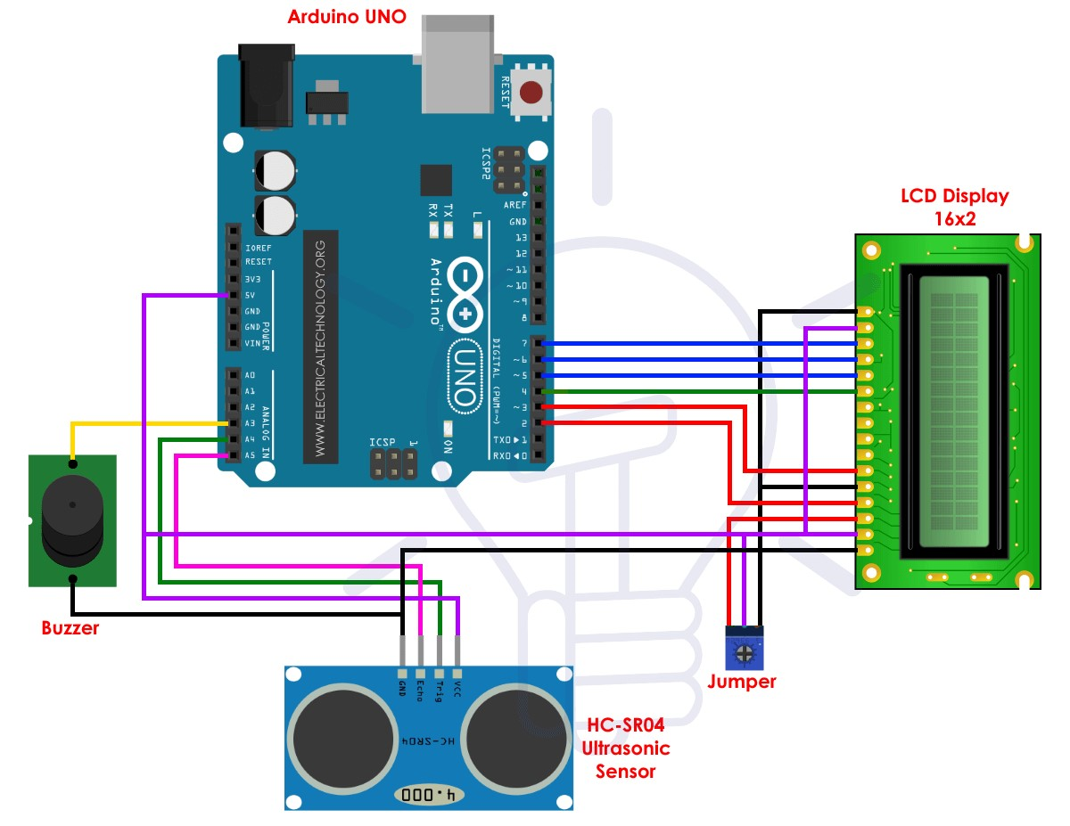

Fig: Flood Monitoring and Early Warning